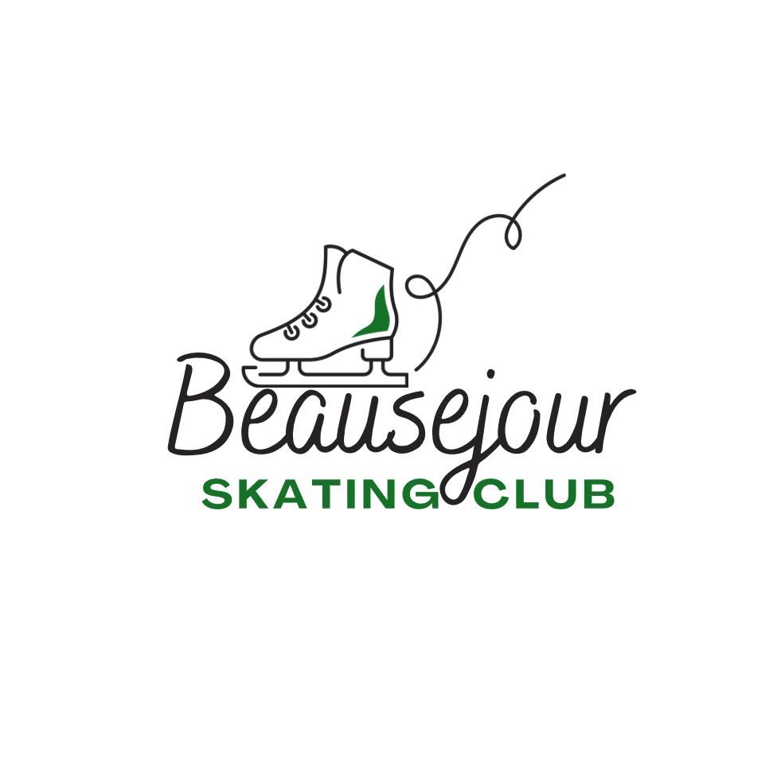

**2025-2026**

**Members Handbook**



**The Beausejour Skating Club**

Welcome to the Beausejour Skating Club! If you are a new member, we thank you for joining, and if you are a returning member, we are glad to have you back! We hope that everyone enjoys this skating season!

In this member handbook, we provide you with the information you will need regarding our skating club and its programs. We are a member of Skate Canada – Manitoba operating under their guidelines and regulations. We follow the Skate Canada – CanSkate and STARSkate programs, with the instruction from NCCP certified coaches and trained Program Assistants.

The Beausejour Skating Club is a non-profit organization, providing skating lessons for children, teens and adults living in the Eastman Region. The club is run by parent volunteers and willingly accepts help from all members and welcomes any suggestions and ideas.

**Depending on the program your child is registered for, please also consult our CanSkate or StarSkate Handbook also, for more information and guidance.**

Please feel free to contact Board Member or our Coaches at any time with any question or concerns!

Happy Skating Season!!

**Contact Information**

Professional Head Coach – Sarah Murkin-Debeuckelaere

Email: [coach_skating@hotmail.com](mailto:coach_skating@hotmail.com)

Professional Coach – Sybil Carello

Email: [loopsandbrackets@gmail.com](mailto:loopsandbrackets@gmail.com)

Club Email: [beausejourskatingclub@gmail.com](mailto:beausejourskatingclub@gmail.com)

Club Website: <https://beausejourskatingclub.uplifterinc.com/>

Facebook/Instagram: Beausejour Skating Club

**Board of Directors**

The board of Directors is elected at the BSC Annual General Meeting. The board is responsible for organizing and managing club affairs for the year. The executive for 2025-2026 season consists of:

**Title Name Email**

President Pam Schirle [pamschirle@gmail.com](mailto:pamschirle@gmail.com)

Vice-President Vacant

Treasurer David Roy [david.roy@live.com](mailto:david.roy@live.com)

Secretary Morgan Roy [morganroy@live.ca](mailto:morganroy@live.ca)

Assessment Coordinator Vacant

Director of Registration Terra Smyk [bsc_registrar@outlook.com](mailto:bsc_registrar@outlook.com)

Director of Fundraising Michelle LaChance [mlymych1@yahoo.com](mailto:mlymych1@yahoo.com)

Director of Ice Show Aimee Epp [aimee.e.benjamin@gmail.com](mailto:aimee.e.benjamin@gmail.com)

Director of Marketing Santana Boulet [santanaboulet@gmail.com](mailto:santanaboulet@gmail.com)

Director of CanSkate Vacant

Director at Large Ashley Elkiw-Buckle [aelkiw@gmail.com](mailto:aelkiw@gmail.com)

Professional Coach Rep Sarah Murkin- [coach_skating@hotmail.com](mailto:coach_skating@hotmail.com)

Debeuckelaere

**Representation**

We are always looking for club members to participate at the meetings or join the Board. We meet once a month. If you are interested in attending a meeting or getting more information about the club executive, simply contact any one of the members listed above and we would be happy to discuss what interests you!!

**BSC Program Information 2025-26**

**CanSkate**

**SunGro Beausejour**

Friday 4:15-5:00 pm

Sunday 10:30 -11:15 am

**What is CanSkate?**

CanSkate is a “learn to skate” program. The fundamentals of skating are taught to prepare skaters for various sports including, STARSkate program, CanPowerSkate, Hockey, Ringette or for a lifetime of recreational skating.

**CanSkate Objectives**

* To provide basic skating instruction in a group situation.
* To introduce skaters to the fundamentals of movements of skating in a safe, fun environment.
* To develop balance, coordination and rhythm through music.
* To enable skaters to move through the Skate Canada system smoothly.
* To encourage lifelong participation in skating.
* To promote physical fitness.

**Additional CanSkate information**

**Is your child ready for CanSkate?**

Each child is different however, **your child must be 4 years old** and meet the following criteria to be ready for the CanSkate program:

* The ability to understand simple instructions and follow directions from a person other than a parent.
* Able to “separate” from a parent and remain on the ice for the 45 mins session.
* Skates that fit properly and support ankles. Hockey skates or figure skates are the best options. **Adjustable skates do not provide the needed support.**
* The ability to walk on the floor with reasonable straight ankles while wearing skates.

**What is happening on the Ice?**

Our Head Coach will provide instruction with support of our trained program assistants who will reinforce instruction, lead activities and perform various tasks as needed by the coach. Each session consist of the following portions:

* Warm up
* Lesson time (skill review, new skills, practice time)
* Group activities (creative expression/skill development, games/action songs)
* Cool down

**STARSkate**

**SunGro Beausejour**

Friday Group 5:00-6:00 pm

Private 6-7:15 p.m.

Sunday Private 9:30-10:30

Group 11:15-12:45

**Please contact our club if you have a child interested in figure skating as there are many options available!**

**STAR 1-5**

Led by NCCP-certified Skate Canada coaches, the STAR 1-5 curriculum is Canada’s premier figure skating program. It lays the groundwork for future champions in singles, pairs, ice dance, and synchronized skating by introducing participants to all the figure skating essentials.

**STAR 6-Gold** is an assessment and event framework program designed for skaters who have completed the STAR 1-5 curriculum. It pushes your skills to the next level, building on what you’ve already learned while introducing exciting advanced figure skating elements.

**StarSkate Group** - This program is for skaters who have advanced from the CanSkate program and who are continuing their skating journey in the Skate Canada STAR program. * Group STARSkate is training with two coaches as a group for the entire session, and coaching fees are included in the price.

\*\***Private STARskate** fees are ICE ONLY and coaching fees are billed by and paid directly to the coach. Coaching for private ice time must be arranged directly with the coach and is dependent on their availability. Should your skater be interested in private lessons, please email the coach directly (email address provided in handbook) to discuss. **

**Refunds:** For CanSkate– The Beausejour Skating Club offers a two-week trial period to decide if your child is ready for either program. If participants are withdrawn from either program within two weeks of starting, a full refund, minus the non-refundable Skate Canada membership fee, will be issued.

**Please Note: During the trial period, our Club and Coaches reserve the right to assess a child’s readiness. Should the parent and or/the coaches not feel the child is ready for the programming, this will be communicated and a refund issued.**

**For all other Skating Programs** – Prorated refunds for medical reasons will be issued (minus the non-refundable Skate Canada membership fee) and will require a medical note.

**Coaching**

All of our Skate Canada Programs are coached by NCCP Certified Coaches. The CanSkate Program is greatly facilitated with the help of trained, volunteer Program Assistants. Our Club coaches this year will Sarah and Sybil who coach CanSkate and group StarSkate. There could also be other Professional Coaches on the ice who give private lessons.

**Coaching Privileges**

The BSC Executive authorizes the coach’s ice privileges and no coach can offer services at the club without approval. Such approval may be refused or revoked if the coaches violate Skate Canada rules and/or their conduct is contrary to club policies or brings into disrepute the image of the club.

**Fundraising**

Each skater is required to summit a $100 fundraising bond upon registration (to a max of 2 bonds per family). If the fundraising requirement is met, you will be reimbursed for this bond. The club provides numerous fundraisers throughout the season to assist members in achieving this amount.

If you wish to stay up-to-date with fundraising programs and deadlines, please ensure we have your email address as all information will be sent via email on a regular basis. If you do not have email, please ensure you check the BSC Bulletin Board as well as our Facebook , as all club and fundraising information will be posted there regularly.

**Volunteering**

We ask that all parents volunteer a small amount of time throughout the season to help support some of the events and programs offered through our club. Some of the events you may be asked to assist with are the ice show (March) and the AGM/Windup.

**Inclement Weather**

*** As of September 26, 2022 the Board changed our previous BSC weather policy and we no longer follow the Sunrise School Division closure due to inclement weather. ***

If the Sungro Center In Beausejour chooses to close due to weather or other unforeseen events, notification will be posted on the BSC and the BSC FB page (and an email will be sent out to all emails on file. If in doubt please feel free to contact our head coach, club president or any other Board Member.

**PARENT RESPONSIBILITIES AND EXPECTATIONS**

* Learn about your skaters' program and how it operates.
* Join our Facebook page and stay current with club updates and information.
* Check out our bulletin board in the Sportsplex Lobby for information also.
* Arrive 15 minutes prior to the start of your ice session and ensure younger children use restrooms prior to entering the ice. This will help to avoid lesson disruption.
* Ensure skaters are wearing proper clothing and skates/equipment.
* Have a parent or designated guardian at the arena during sessions.
* Do not “drop and go”; a responsible adult must be present in the arena.
* Parents are not allowed on the ice-surface or in the players box during lesson times - unless they are acting in an official club capacity. Parents are not insured by Skate Canada. Parents must move to either the lobby, stands, or around the walking trail after their child is safely in the box or on the ice surface for their lesson.

**ANNUAL ICE SHOW**

Each year, the Beausejour Skating Club puts on a themed annual ice show! This is typically held towards the end of our programming at the end of March, on a Friday evening.

All BSC skaters from CanSkate and StarSkate are welcome to join in the fun. We love seeing everyone take part and share their progress with family and friends. It’s all about celebrating the hard work, and energy that goes into becoming better skaters.

**For CanSkaters:** Skaters will be grouped by their colour level (Green, Blue, Red) and will be ready to show off their skills in an ice circuit with their coach and regular PAs on the ice to support them. They will all practice during their regular skating sessions, so there are no additional practices required!

Each group of skaters will be assigned a fun theme and song. We do ask for parent assistance involvement in costume planning/organizing. **Please note: This may require an extra cost of $15-25.00.**

**For StarSkaters:** Skaters will be assigned group numbers/or solos by coaches and will perform these numbers throughout the show!

Our Ice Show is very well supported/attended by our community and a great opportunity to support our local talent and for your child to show off their hard work and skills! We encourage you to plan to attend! We would love to have you there!

If you would like to be a part of planning, organizing or volunteering with our ice show, please contact our Ice Show Director.

**CANSKATE AND STARSKATE HANDBOOKS:** Depending on your skater’s program, please refer to our CanSkate or StarSkate Handbooks for more information and guidance.

**HAPPY SKATING. WE CANT WAIT TO SEE YOU ON THE ICE!**